RESOLUTION NO.__________

RE: CERTIFICATE OF APPROPRIATENESS UNDER THE
PROVISIONS OF THE ACT OF THE PENNSYLVANIA
LEGISLATURE 1961, JUNE 13, P.L. 282 (53
SECTION 8004) AND BETHLEHEM ORDINANCE NO.
3952 AS AMENDED.

WHEREAS, it is proposed to replace the existing garage doors and asphalt siding at 335-337 Vine St.

NOW, THEREFORE, BE IT RESOLVED by the Council of the City of Bethlehem that a Certificate of Appropriateness is hereby granted for the work.

Sponsored by: (s)

(s)

ADOPTED BY COUNCIL THIS DAY OF

(s)
President of Council

ATTEST:

(s)
City Clerk

HISTORIC CONSERVATION COMMISSION

CASE # 418 – It is proposed to replace the existing garage doors and asphalt siding at 335-337 Vine St.
OWNER/APPLICANT: Cartlin Properties, LLC/ Greg Heitman

The Commission upon motion by Mr. Evans and seconded by Mr. Silvoy adopted the proposal that City Council issue a Certificate of Appropriateness for the proposed work described herein:

- The proposal to replace the existing garage doors and asphalt siding at 335-337 Vine St. was presented by Beth Starbuck.

- The proposed garage doors are paneled overhead doors similar to the neighboring doors. They should be painted a single color.

- The asphalt siding is proposed to be replaced with vinyl clapboard consistent with prior approved siding on the second floor addition.

- The proposed motion was unanimously approved, Ms. Starbuck abstained due to a conflict of interest.

CU: ldbd

By: 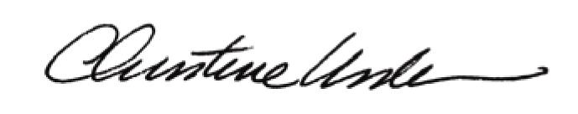

Date of Meeting: June 18, 2012 Title: Historic Officer

