RESOLUTION NO.__________

RE: CERTIFICATE OF APPROPRIATENESS UNDER THE
PROVISIONS OF THE ACT OF THE PENNSYLVANIA
LEGISLATURE 1961, JUNE 13, P.L. 282 (53
SECTION 8004) AND BETHLEHEM ORDINANCE NO.
3952 AS AMENDED.

WHEREAS, it is proposed to install a sign at 306-308 Brodhead Ave.
.

NOW, THEREFORE, BE IT RESOLVED by the Council of the City of Bethlehem that a Certificate of Appropriateness is hereby granted for the work.

Sponsored by: (s)

(s)

ADOPTED BY COUNCIL THIS DAY OF

(s)
President of Council

ATTEST:

(s)
City Clerk

HISTORIC CONSERVATION COMMISSION

CASE # 413 – It is proposed to install a sign at 306-308 Brodhead Ave.
OWNER/APPLICANT: Fred Achey / Colin Bell, Myers & Bell Insurance Agency

The Commission upon motion by Mr. Cornish and seconded by Mr. Heitmann adopted the proposal that City Council issue a Certificate of Appropriateness for the proposed work described herein:

- The proposal to install a sign at 306-308 Brodhead Ave was presented by Mark Hoffman.

- The sign will read “Hoffman Insurance consultants, LLC, Myers and Bell Insurance Agency, Inc, with the telephone number, Auto, Home, Business, Health, Life” in English and Spanish. The sign’s colors are blue, yellow, and white.

- The sign has already been installed in the existing box sign.

- The internal lighting of the old box sign may not be used since internally illuminated box signs are not historically appropriate.

- Additional window signage and wall sign on the north side of the building must be reviewed by the Historic Commission at a later date.

- The proposed motion was unanimously approved.

CU: cu

By: 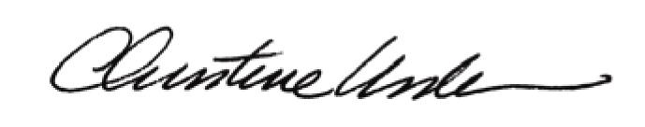

Date of Meeting: April 16, 2012 Title: Historic Officer

